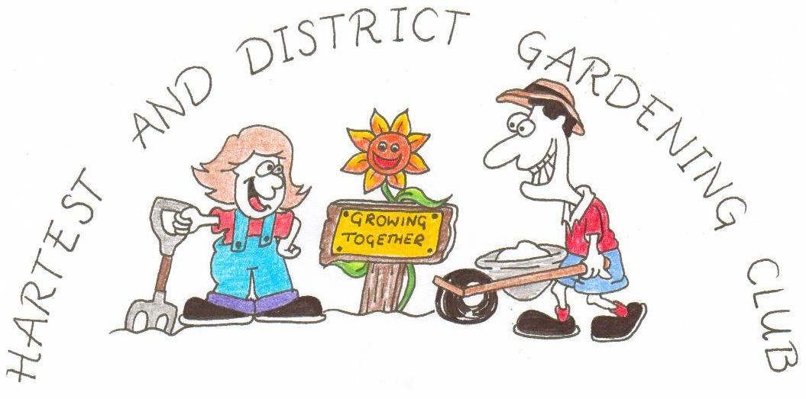
www.hartestgardeningclub.info

ANNUAL SHOW

In the Institute Hall at Hartest
at 2.30 pm on
Saturday September 14th 2019

TIMETABLE

Friday September 13th Staging from 6.00 pm to 7.00 pm.

Saturday September 14th Staging from 9.30 am to 11.00 am.
Judging at 11.15 am.
Open to public at 2.30 pm.
Awards at 3.00 pm.
Raffle at 3.30 pm.

RULES
- The show is open to any exhibitor with the exception of classes 75 to 77.
- All exhibits must have been grown or created by the exhibitor.
- The Judges decision is final on all matters of doubt.
- The Garden Club cannot be responsible for containers used to exhibit.
- Exhibitors may submit only one entry per class.
- There is an entry charge of 25p for each exhibit (other than in Section 5).
- Method of scoring : 4 points for 1st place in a class, 3 points for 2nd,
2 points for 3rd and 1 point for Highly Commended.

VICTORIA SANDWICH – CLASS 97 FRUIT CAKE - CLASS 98
6 oz margarine 6 oz soft margarine
6 oz caster sugar 6 oz caster sugar
6 oz self raising flour 8 oz self raising flour
3 eggs 3 large eggs
½ level teaspoon mixed spice
10oz luxury mixed fruit
1. Heat oven to 180ºC/Gas Mark 4. 2oz glacé cherries
2. Grease two 7” sandwich tins.
3. Cream margarine and sugar. 1 . Heat oven to 160ºC/Gas Mark 3.
4. Beat in eggs, one at a time, adding 2. Place the margarine, caster sugar,
a little flour with each. flour, eggs and mixed spice in a food
5. Gently fold in remaining flour. processor and pulse until all the
6. Add a tablespoon of milk if the mixture is creamed.
mixture seems a little stiff. 3. Fold in the mixed fruit and cherries.
6. Place even amounts in tins and 4. Line a 2lb loaf tin with greaseproof bake for 20-25 minutes. paper, fill with the mixture and place on 7. When cool, fill with jam, and dust the middle shelf of the oven for 1½ to with caster sugar. 1¾ hours.

