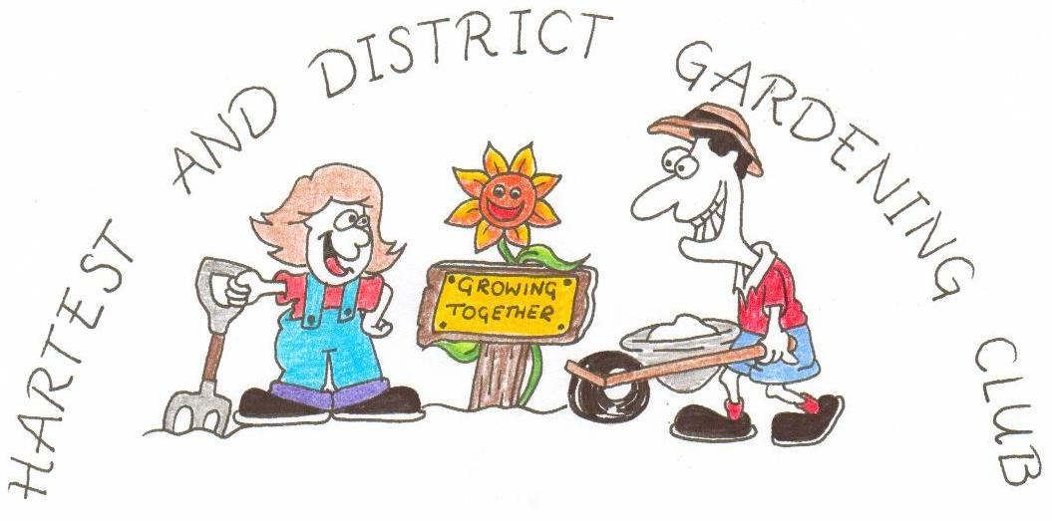
www.hartestgardeningclub.info

ANNUAL SHOW

In the Institute Hall at Hartest
at 2.30 pm on
Saturday September 11th 2021

TIMETABLE

Friday September 10th Staging from 6.00 pm to 7.00 pm.

Saturday September 11th Staging from 9.30 am to 11.00 am.
Judging at 11.15 am.
Open to public at 2.30 pm.
Awards at 3.00 pm.
Raffle at 3.30 pm.

RULES
- The show is open to any exhibitor with the exception of classes 75 to 77.
- All exhibits must have been grown or created by the exhibitor.
- The Judges decision is final on all matters of doubt.
- The Garden Club cannot be responsible for containers used to exhibit.
- Exhibitors may submit only one entry per class.
- There is an entry charge of 25p for each exhibit (other than in Section 5).
- Method of scoring : 4 points for 1st place in a class, 3 points for 2nd,
2 points for 3rd and 1 point for Highly Commended.

Some pictures from the last show:

